DEAF-BLIND SERVICE CENTER
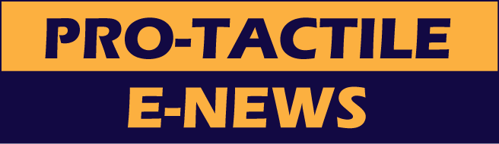
OCTOBER 2013

Notes from the Director
Fall is coming very soon and I’m not ready to say goodbye to summer. Hope you all had a chance to enjoy it!

I am thrilled to say that Cathy Hoog has been working part-time as the SSP Coordinator since July 2013. I want to give many thanks to JennyLynn Dietrich who worked as the temporary SSP Coordinator and to Elizabeth Bass who assisted with the paperwork related SSP services for the past year. I am also thankful to the Deaf-Blind community for its patience with us during our search for a new coordinator.

I had two work trips this summer that I want to share with you.

Minnesota Trip, June 23rd-26th

Tami Berk, the Director for the Deaf-Blind Program at the Lighthouse for the Blind, and I visited various agencies in Minnesota that provide services for the Deaf-Blind Community there.

Below is a list of agencies we visited:

- Department of Human Services (DHS) - Deaf and Hard of Hearing Services (DHHS)
- Deaf-Blind Service Minnesota (DBSM)
- Low Vision Resources (VLR)
- Deaf-Blind Beading Class
- State of Services for Blind (SSB)
- Blind, Inc (Training Center for Blind and Hearing Individuals)
- Deaf-Blind Social at Mall of America

We discovered much about the services each agency provides and how funding is provided for SSP services. It was amazing to learn about all the services. After visiting the agencies, we went to Camp Courage with a group of Deaf-Blind campers in Maple Lake, Minnesota, June 27th-30th. The camp was awesome and beautiful and the activities were creative and FUN! I am grateful the Deaf-Blind community invited me to participate as a camper at the last minute. I had a great time and enjoyed getting to know everyone.

Michigan Trip, August 19th-25th

In 2010, the National Consortium of Interpreter Education Centers (NCIEC) published a peer taught Deaf self-advocacy curriculum. In 2012, NCIEC enhanced the curriculum and published “Deaf Self-Advocacy Training: Curriculum Tool Kit, Second Edition” (DSAT). As part of its development, NCIEC, working with two Deaf-Blind consultants and an expert review team, adapted the Second Edition for Deaf-Blind audiences.

A four-day “Train the Trainer” seminar was located at the Holley Family Village in Brooklyn, Michigan. NCIEDC picked to a select group of 10 Deaf-Blind advocates. The purpose of the seminar was to prepare 10 Deaf-Blind advocates to be able to effectively conduct consumer trainings. The names of the Deaf-Blind advocates who participated were: Andy Granda from California, Angela Theriault from Washington, Ashley Benton from North Carolina, Bryen Yunashko from Illinois, Chris Woodfill from New York, Elaine Ducharme from Massachusetts, Karen Parks from Colorado, Kim Powers-Smith from Texas, Vicky Maglio from Florida, and Vincent Lee Clark from Minnesota. Laura Thomas and Garcia Peterkin, who are both Deaf, trained us on the use of presentation tools, hands-on activities, group activities, etc. from the curriculum.
DBSC is planning to provide Self-Advocacy training in the future. We will send out a flyer with more details once a date has been set.

SSP Coordinator
DBSC is pleased to welcome aboard Cathy Hoog, who is hard-of-hearing and a CODA (Child of Deaf Adult). She has been working part-time as DBSC’s SSP coordinator since last July. Her various professional experiences include: Interpreter, Case Manager, Advocate, Trainer, Systems Advocate, Author, and Grandmother to 14 grandkids! We are excited about the skills and rich experience she will bring to DBSC. Her contact information is:
Cathy Hoog
ssp@seattledbsc.org
(VP) 206-552-7842
(Voice) 206-726-1950

If you are interested in participating in SSP training or becoming a volunteer SSP or paid SSP, please contact Cathy.

National Deaf-Blind Equipment Distribution (NDBEDP) Outreach
We are pleased to share some good news with you. DBSC has been awarded a one-year contract from ODHH (Office of Deaf and Hard-of-Hearing) to promote statewide awareness of NDBEDP. DBSC will also be providing assistance for filling out the NDBEDP application form.

The Twenty-First Century Communications and Video Accessibility Act of 2010 (CVAA) authorizes the Federal Communications Commission (FCC) to provide up to $10 million annually for local programs to distribute communication equipment to low-income deaf-blind individuals. The goal is to provide access to communication tools like email and text using modern technology, such as: a Braille display, BrailleNote, ZoomText, tablet, computers, etc.

If you are interested in learning more, would like to host a presentation or a display booth, or need assistance in filling out an NDBEDP application, please contact Angela Theriault at atheriault@seattledbsc.org or 206-257-2754.

Spaghetti Dinner Event
Come join DBSC’s Staff & Board for a fun afternoon of socializing & spaghetti!

Saturday, October 5, 2013 at HSDC (Hearing, Speech & Deafness Center)
$20.00 per person – SSP’s free!
12 noon to 3:00 pm
(Social: 12:00-1:00)
(Food & Fun: 1:00-3:00)

We are looking for volunteers for the Spaghetti dinner that will be held on Oct 5th. We hope you can join us! Come and try out your SSP skills, meet other SSPs and the Deaf Blind community, and support our fundraising efforts! Thank you for your interest and support of DBSC. If you are interesting in volunteering, please contact Cathy Hoog at ssp@seattledbsc.org.

SSP Training
Finally, SSP Training is coming! We are ready to start classes for the fall of 2013, and the schedule is as follows:

Thurs, Oct 17th, 5:30-8:30 PM
Tues, Oct 22nd, 5:30-8:30 PM
Thurs, Oct 24th, 5:30-8:30 PM
Sat, Nov 2nd, 9:30 AM-12:30 PM

If enough people have concerns about the above dates, we can adjust times or dates.

The trainings will be held at DBSC and we are asking a fee of $30.00 to cover snacks and handouts. Please let Cathy Hoog know if you are interested in attending and/or applying to become a paid SSP.

Donate to DBSC
If you would like to donate DBSC’s programs & services, you can donate on our DBSC website! Click here to donate.

DBSC is on Facebook!
Click here to join DBSC on FACEBOOK!

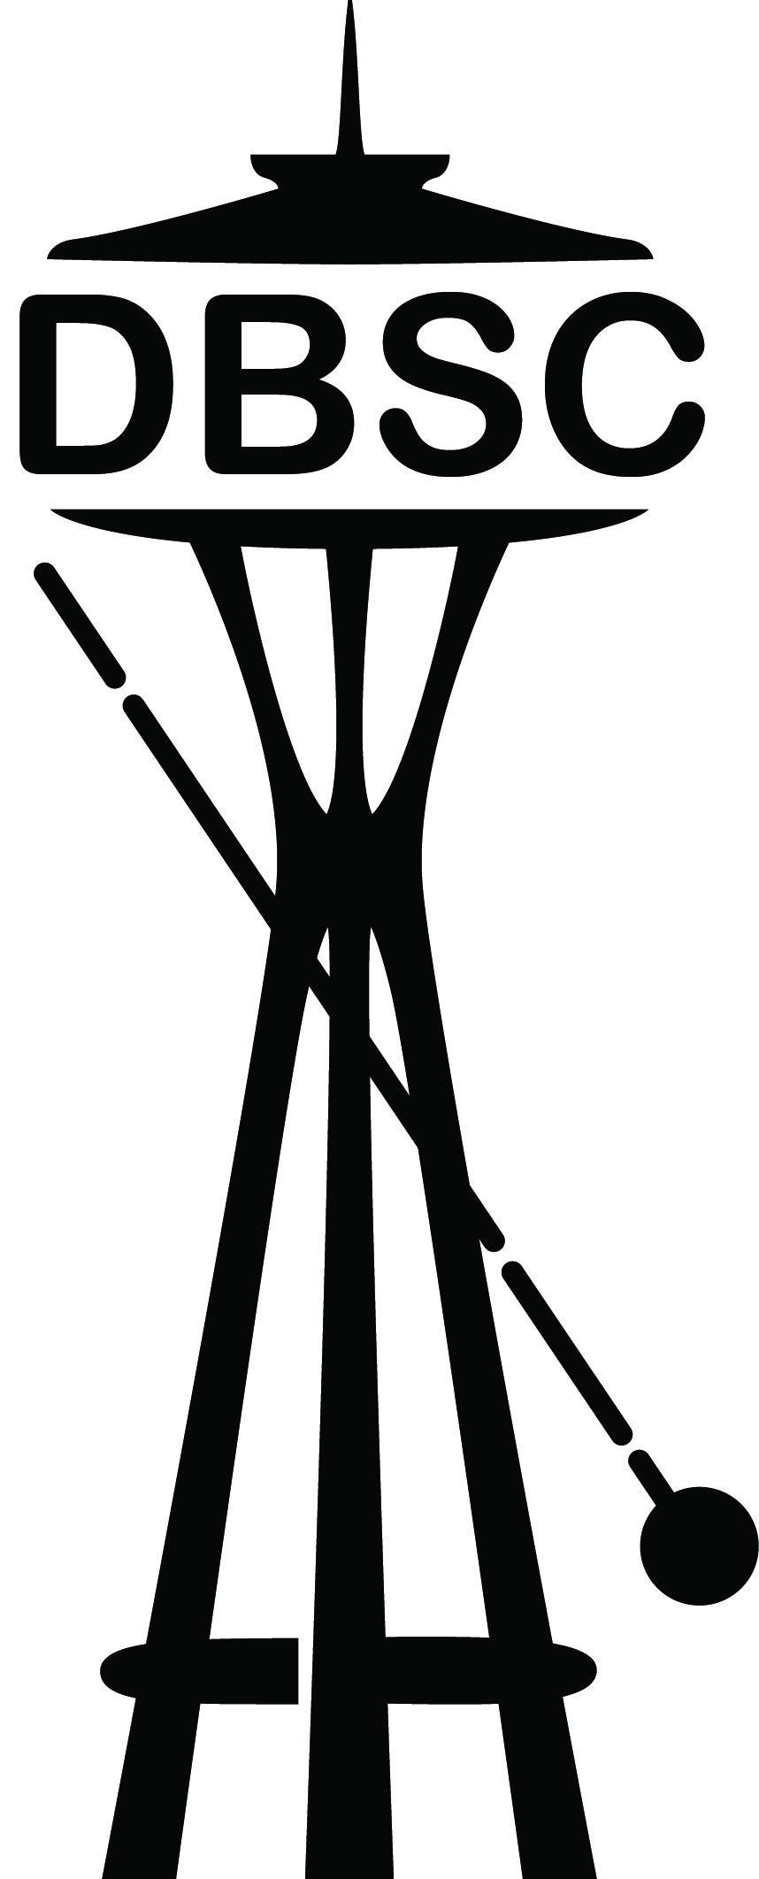
Deaf-Blind Service Center
1620 18th Avenue, Suite 200
Seattle, Washington 98122
TTY (206) 323-9178
VP (206) 455-7932
info@seattledbsc.org
www.seattledbsc.org

To unsubscribe to the monthly Pro-Tactile E-News, please email info@seattledbsc.org.

