DEAF-BLIND SERVICE CENTER
NOVEMBER 2013

Message from Executive Director
Thank you to all those who supported DBSC by participating in the Walk-A-Thon and the Spaghetti Dinner. Both events were lots of fun! Because of your generosity, DBSC raised $6,430.80 for expanding the SSP Program. Thank you for making this possible and we are looking forward to your involvement next year!
May all the joys of this Holiday Season be yours throughout the New Year!

DBSC Walk-A-Thon
What an amazing fundraiser! It was so much fun! This year’s Walk-A-Thon was Saturday, September 14th at Alki Beach and included some new activities - four-person Surreys and four-person Tandem bikes. Some people walked, others walked and rode. Even though the weather was chilly, no one seemed to be too bothered. Everyone enjoyed themselves and we raised $5,260.80. Debbie Sommer ($969) and Jackie Engler-Morris ($520) won prizes for collecting the highest pledges.
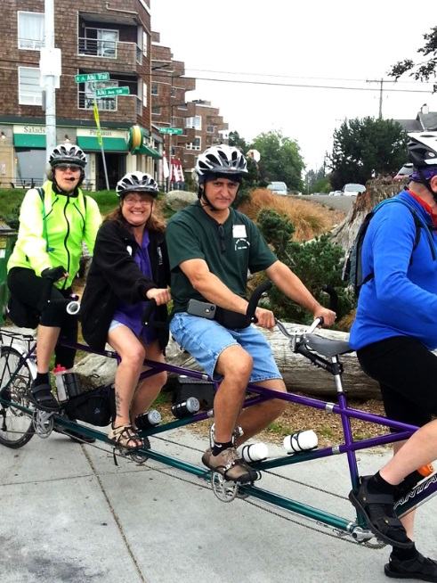
Special thanks to our Walk-A-Thon Committee (John Romish, Jorgé Aristizabal, and Merrilee Avila) for a job well-done, and to our wonderful sponsors (Key Bank, Sorenson, THAT! Interpreter Services, Trader Joe’s, and Wheel Fun Rentals) who helped make our event such a success!
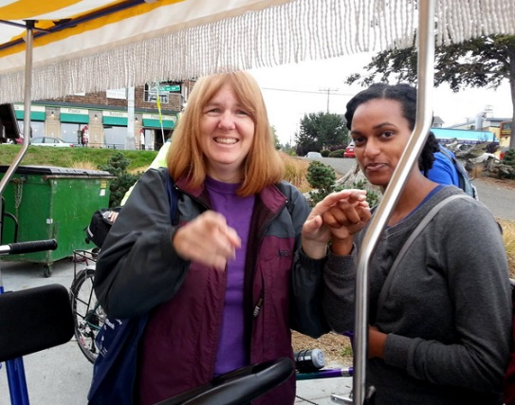
Picture above: Jorgé Aristizabal and Cheryl Lind on a four-person tandem with captains from Wheel Fun Rentals.
Picture on left: Jackie Engler-Morris and Napal Tesfai (SSP).
Be sure to come and join us September 2014 for our 11th Annual Walk-A-Thon!

Spaghetti Dinner
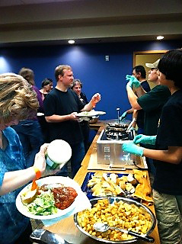
The Spaghetti Dinner was held Saturday, October 5th at HSDC (Hearing, Speech & Deafness Center) and included both a homemade vegetable sauce and a meatball sauce, salad, bread, dessert, and drinks. Everything was delicious! There were also raffle prizes. Many, many thanks to our Spaghetti Committee (Michelle Miles, Merrilee Avila, and Jorgé & Doris Aristizabal)
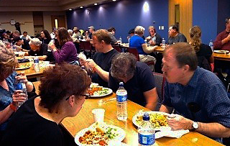
Picture above: Elinor Powicke, Jeff Foster, Caryn Tenin, Jason Wells, and many others enjoying the spaghetti dinner.
Picture on the right: Jorgé Aristizabal, Michelle Miles, and Julian Aristizabal serving spaghetti to Jason Wells, Caryn Tenin, and a long line of other DBs & SSPs.

Bingo
DBSC Presents… Bingo! To be held on Saturday, January 11, 2014, 1:00-4:00 pm in the HSDC Conference Room (1625 19th Ave, Seattle). Suggested donation is $20 and will include: 3 bingo cards, prizes, and light refreshments. Additional Bingo cards can be requested ($5 – suggested donation). You can pay at the door using debit/credit card, check, or cash.
Contact Cathy at choog@seattledbsc.org to request an SSP. Request deadline: Friday, December 20, 2013.

Mini-Braille Calendars
DBSC now has mini-Braille calendars available, both contracted and un-contracted.
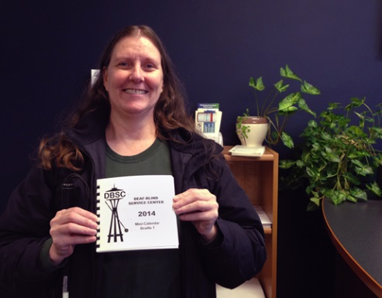
Suggested donation for the calendar is $5. Samples are available at DBSC. Email Elizabeth at ebass@seattledbsc.org to order yours today.
Picture on right: Nancy Sommer modeling the first calendar.

ODHH Funding
We are excited to announce that ODHH decided to grant DBSC $20,000 for two years. The purpose for this funding is to provide case management services to “At-Risk Clients” throughout Washington State, with the exception of King, Pierce, and Snohomish counties. DBSC has already been providing services to those counties. “At-Risk Clients” means those clients that face serious situations.

Examples of serious situations:
- Inability to receive reasonable accommodations during a life and death emergency or the provision of medical services
- Rapid hearing or vision loss
- Inability to do one or more of the following tasks without assistance: grocery shopping, housekeeping, doing own laundry, managing own prescription, preparing meals, paying bills, protecting personal finances or property, taking care of own health, taking safety precautions, maintaining personal hygiene and grooming or doing daily activities
- Living or staying in an inaccessible, unsafe or unstable dwelling, housing or shelter
- Living in domestic violence situation
- Inability to make medical, health, or life-altering decisions independently
- Lack of access to transportation services
If you, a member of your family, or your friend have experienced of one or more these above situations, DBSC can assist you. Please contact DBSC at info@seattledbsc.org or 206-455-7932.

NDBEDP (National Deaf-Blind Equipment Distribution Program)
The Twenty-First Century Communications and Video Accessibility Act of 2010 (CVAA) authorizes the Federal Communications Commission (FCC) to provide up to $10 million annually for local programs to distribute communication equipment to low-income deaf-blind individuals. The goal is to provide them access to communication tools like email, text, and call using modern technology to interact with the world as an involved member of society.
Types of FREE Equipment Available:
- Braille Devices: Braille Display & BrailleNote
- Computers & Tablets
- Software: ZoomText, Jaws, Window-Eyes, etc.
- Phones: Smartphones, Amplified Phones, Cap Tel, etc.
Hearing & Visual Loss Prerequisites:
- Have a central visual acuity of 20/200 or less in the better eye with corrective lenses, or a field defect such that the peripheral diameter of visual field subtends an angular distance no greater than 20 degrees, or a progressive visual loss having a prognosis leading to one or both these conditions.
- Have a chronic hearing impairment so severe that most speech cannot be understood with optimum amplification, or a progressive hearing loss having a prognosis leading to this condition.
Income Eligibility:
Applicant must meet income requirements that do not exceed 400 percent of the Federal Poverty Guidelines. Example: below $45,960 for 1 person or $62,040 for 2 people.
Contact Angela Theriault at atheriault@seattledbsc.org or 206-257-2754 at the Deaf-Blind Service Center for more information or to apply.

Holiday Closures
DBSC will be closed:
- Thanksgiving - Thursday, 11/28 and Friday, 11/29
- Christmas - Thursday, 12/25 and Friday, 12/26

Donate to DBSC
If you would like to donate DBSC’s programs & services, you can donate on our DBSC website! Click here to donate.

DBSC is on Facebook!
Click here to join DBSC on FACEBOOK!

Deaf-Blind Service Center
1620 18th Avenue, Suite 200
Seattle, Washington 98122
TTY (206) 323-9178 ● VP (206) 455-7932
info@seattledbsc.org ● www.seattledbsc.org

To unsubscribe to the monthly Pro-Tactile E-News,
please email info@seattledbsc.org.

