DEAF-BLIND SERVICE CENTER
PRO-TACTILE NEWS – APRIL 2014

Message from Angela Theriault, Executive Director

Spring is finally here! Hope you are enjoying looking at all the many blossoms!

I am excited to announce that Jorgé Aristizabal has become DBSC’s Board President. Congratulations, Jorgé! I am looking forward to working with him.
I also have bitter sweet news. Merilee Avila, Pat Cave, and John Romish have left DBSC’s board and they will be greatly missed. We want to recognize all the time and commitment they gave in support of DBSC’s mission. Many, many thanks for their cherished volunteer work over the last several years.

Our Bingo fundraising event was a blast and a huge success. The room was packed with people laughing and having fun playing Bingo. I felt thrilled and inspired. Many thanks for the wonderful support DBSC received. The Bingo committee has agreed that DBSC will host another Bingo event next year.

Message from Jorgé Aristizabal, Board President

I am thrilled to be the new DBSC Board President. Let me to introduce myself. I am Deaf-Blind with Ushers Syndrome, was born in Colombia, and work for the Lighthouse for the Blind. I am also highly motivated to support DBSC and help it achieve success.

Speaking of success - what a thrilling Bingo fundraiser! DBSC raised an amazing $1,430! Many thanks for your support! Waving hands and stomping feet!

Bingo Fundraising Event

What a surprising fundraising success! DBSC had its first Bingo fundraising event in the HSDC conference room on Saturday, March 15th afternoon. Congratulations to the people who won during Bingo, the raffles, and the silent auction. Hooray - Many thanks for all the support for DBSC!

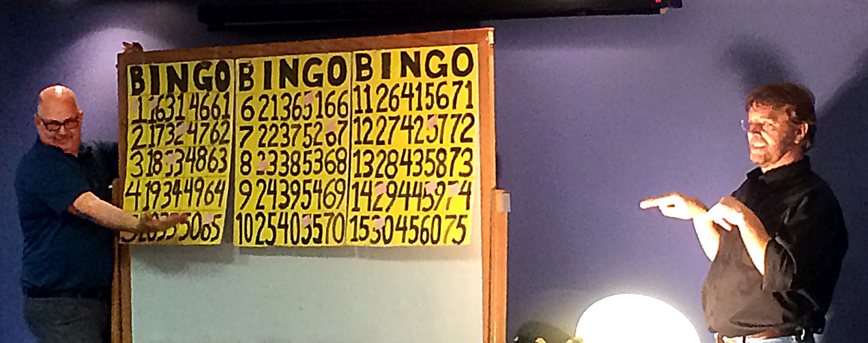
Picture of John & Billy!

Thank you to Billy Seago, who did a wonderful job as host. He has a great sense of humor! And thank you to John Plecher, aka Vanna White, who did an amazing job as Billy’s assistant.

Thank you to our sponsors: Museum of Flight, Central Co-Op, Agua Verde Café & Paddle Club, Tutta Bella, McMenamin’s Pubs & Breweries, PCC Natural Markets, Argosy Cruises, Angela Theriault, Ride the Ducks of Seattle, Marlies Egberding & Ritch Sorgen, Wicked Cellars, Costco, Seattle Seahawks, Seattle Sounders, & Erin Ross!

Thank you to Cathy Hoog, DBSC’s SSP coordinator, who worked hard to recruit SSPs and match them up with Deaf-Blind participants. With much appreciation and tons of gratitude… Thank you to the SSPs who sacrificed their Saturday afternoon to support DBSC and the DB community.

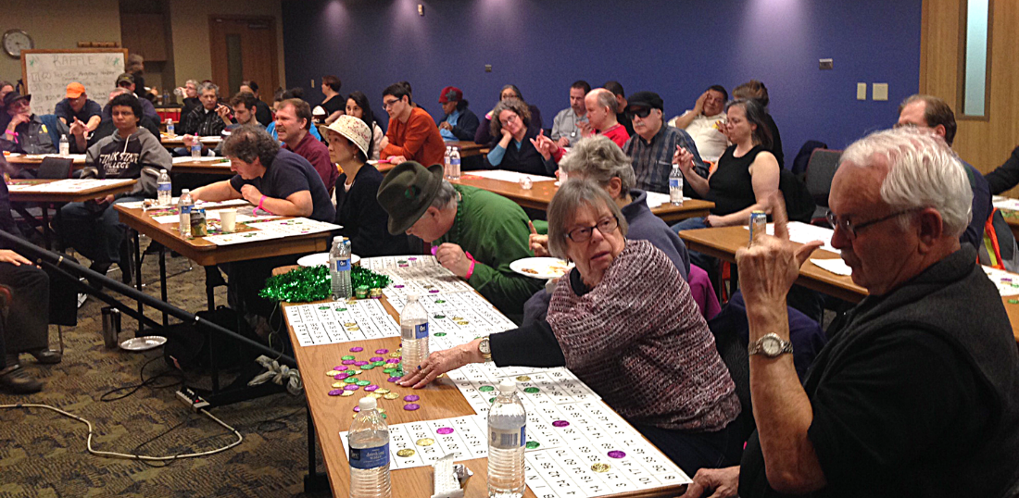
Picture of the many players & volunteers!

Lastly, thank you to our Bingo Committee: Jorgé Aristizabal, Jason Wells, Erin Ross, and Angela Theriault for making this event a success!
Watch for another Bingo Fundraising Event next year!

Other Great News!

DBSC has again received a $15,000 grant from the Elizabeth A. Lynn Foundation to support DBSC’s SSP Program. More waving and stomping of feet!

Medical Interpreting Concern

Until recently, Virginia Mason Medical Center and Group Health Corporative had a contract for interpreter services with International Language Service (ILS). Unfortunately, ILS has decided to close its business. This closure will have a big impact on the Deaf-Blind Community. First, there are not many tactile interpreters. Second, many of the interpreters who are experienced with working with Deaf-Blind are not willing to work with the new interpreting agency, Dynamic Language. They disagree with Dynamic Language’s contract terms and fee schedule. Therefore, you may experience appointment cancellations or interpreters who are not qualified.

DBSC strongly encourages you to contact Dynamic Language and give them a list of your preferred interpreters. Contact information is 206.244.6709 and web@dynamiclanguage.com.

If you experience an appointment cancellation or your interpreter was not qualified, you may contact DBSC for assistance in filing a complaint.

Communication Facilitator (CF) Program Update by Jackie Engler-Morris

Our CF program has become busier as more Deaf-Blind are requesting CF service. Our currents CFs have been hard at work providing our community with access to videophone communication.

As you know, ODHH’s NDBEDP has been distributing telecommunication equipment to DB consumers around the state, including laptops and tablets. Now is a great time for you to start thinking about having CF services in your home. Yes! We can provide CF services to you in your own home!

How does it work?

A CF can meet you at your home if:

- You have a laptop/tablet with a built-in video camera and internet/Wi-Fi access.
- You have access to internet/Wi-Fi. The CF can bring a laptop or tablet with a built-in camera that is able to connect to the internet.

During your call, the CF will sit near you and copy sign the person on the screen using your preferred communication method: tactile, close vision, or tracking. Then, you can respond yourself. That’s Communication Access! You can make VP calls to the people you want to talk with – family, friends, businesses, etc.

All CFs are trained by DBSC staff and are required to follow strict policies and guidelines - such as a code of ethics that includes confidentiality, accuracy, etc.

For more information about the CF program or if you have questions, contact Jackie Engler-Morris at jengler@seattledbsc.org.

AmazonSmile

If you shop Amazon.com, try AmazonSmile. AmazonSmile is part of Amazon.com. The difference is when customers shop on AmazonSmile, the AmazonSmile Foundation donates 0.5% of the price of eligible purchases to the charitable organization selected by the customer.

When first visiting AmazonSmile, customers are prompted to select a charitable organization. After selecting their favorite organizations customers may browse or shop at AmazonSmile. There is no cost to the charitable organizations or to the customers and AmazonSmile does not deduct any fees from the donation amount.

So visit: www.smile.amazon.com, select DBSC as your charity and have fun shopping!

Save these Dates:

• Seattle Foundation’s GiveBIG Day - May 6, 2014. For more information, visit: Seattlefoundation/DBSC (www.seattlefoundation.org/npos/Pages/Deaf-BlindServiceCenter.aspx)

• DBSC/WSDBC Picnic - Saturday, August 9, 2014
The picnic will be held at Woodland Park, Shelter #6, from 10 am to 2 pm. More information will be posted later on DBSC’s website.

• DBSC’s Annual Walk-A-Thon - Saturday, September 13, 2014, at Alki Beach. More information will be posted later on DBSC’s website.

Correction to September’s Newsletter

September’s Pro-Tactile News stated that Ashley Benton, an advocate who attended the four-day “Train the Trainer” seminar in Brooklyn, Michigan was from North Carolina. Ashley is actually from South Carolina.

Donate to DBSC

If you would like to donate DBSC’s programs & services, you can donate on our DBSC website! Click here to donate.

DBSC is on Facebook!
Click here to join DBSC on FACEBOOK!

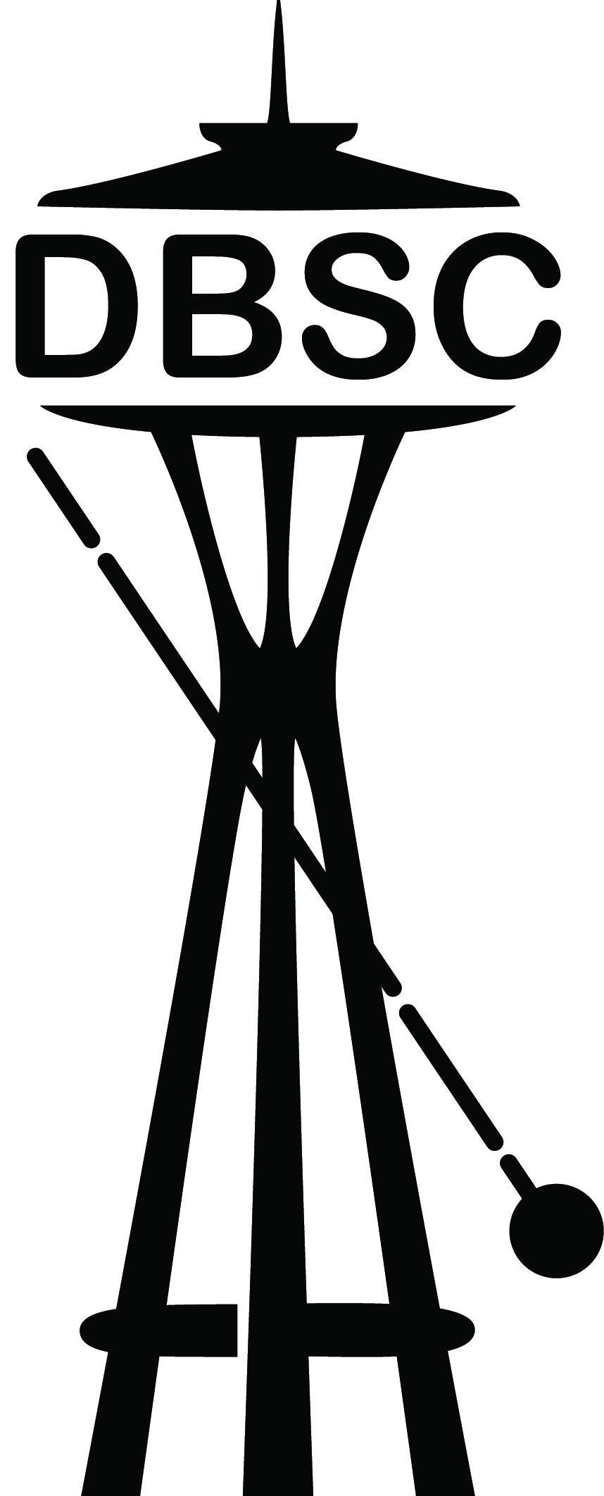

Deaf-Blind Service Center
1620 18th Avenue, Suite 200, Seattle, WA 98122
VP (206) 455-7932 ● TTY (206) 323-3644
Voice Line: 206-323-9178
info@seattledbsc.org ● www.seattledbsc.org

To unsubscribe to the monthly Pro-Tactile E-News,
please email info@seattledbsc.org.

